Draw a Dump Truck

If you can draw some circles and rectangles, you can learn how to draw a dump truck. It really is that easy.
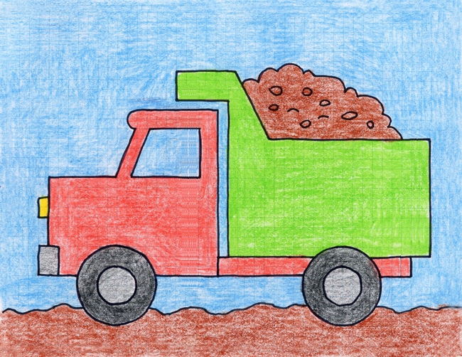
This tutorial is good for early elementary students, perhaps while they are studying a general theme of transportation. The shapes are basic and familiar, which is a good start for those just learning how to draw.

MATERIALS
- Draw a Dump Truck
- Drawing paper
- Black marker
- Crayons

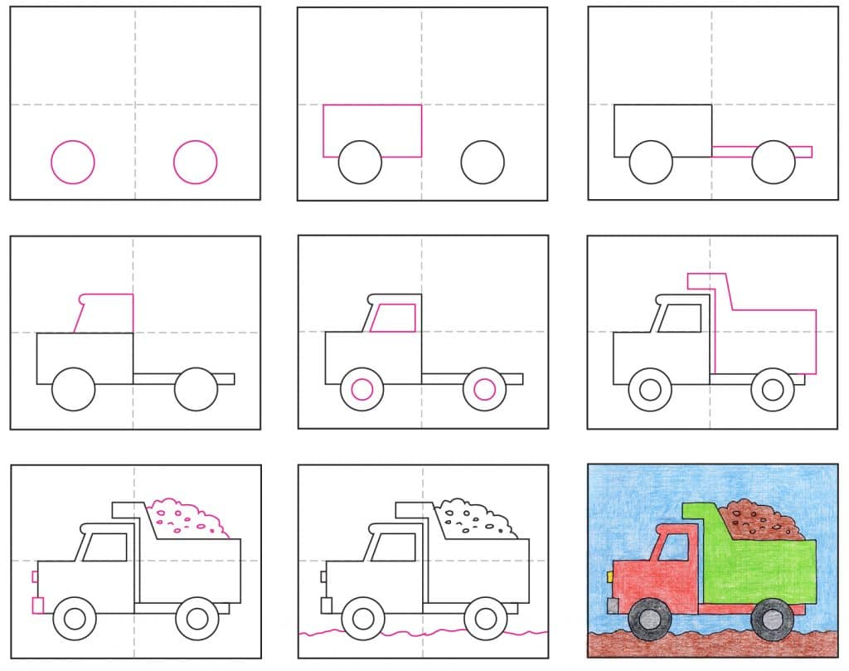
- Make guidelines. Draw two circles.
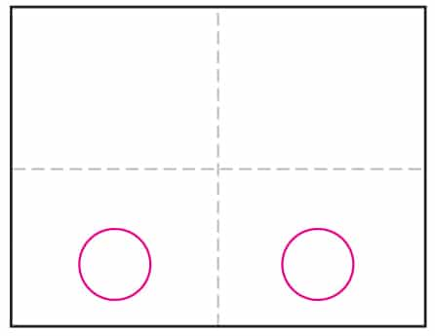
- Draw rectangle around the front .
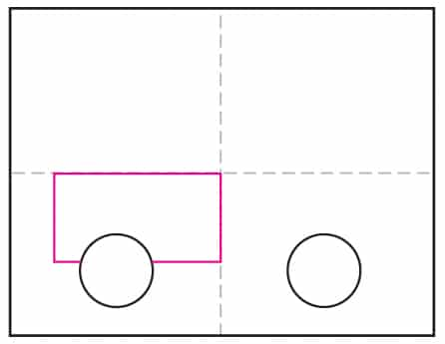
- Add base to back of truck.
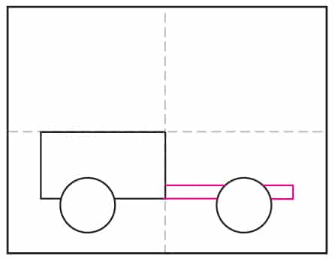
- Draw the cab in the front.
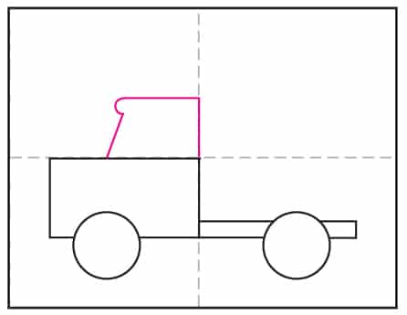
- Add a window and hubcaps.
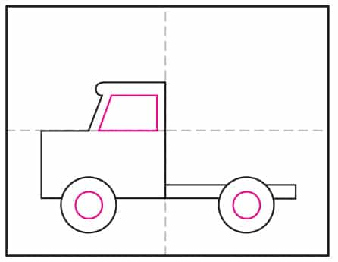
- Draw the back of the truck.
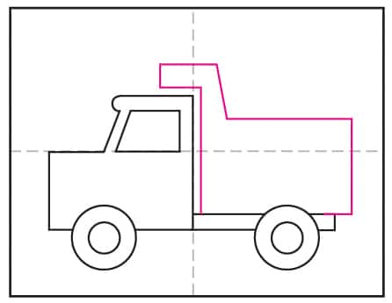
- Finish front lights and bumper. Fill with dirt.
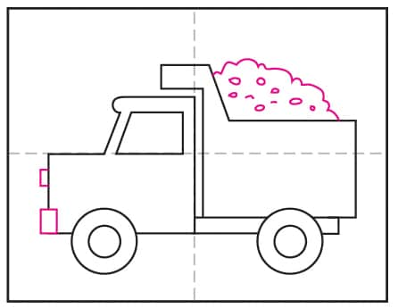
- Draw a bumpy ground line.
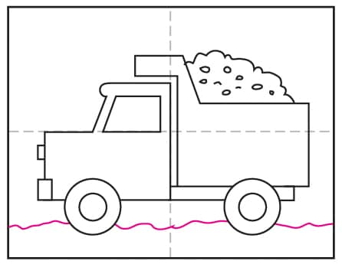
- Trace with a marker and color with crayons.
