- Your Cart - $0.00

Elements of Art: Space in a Landscape

One of the Elements of Art, Space, can also be illustrated with a fore, midground and background landscape lesson. Having all three adds more space to your art.
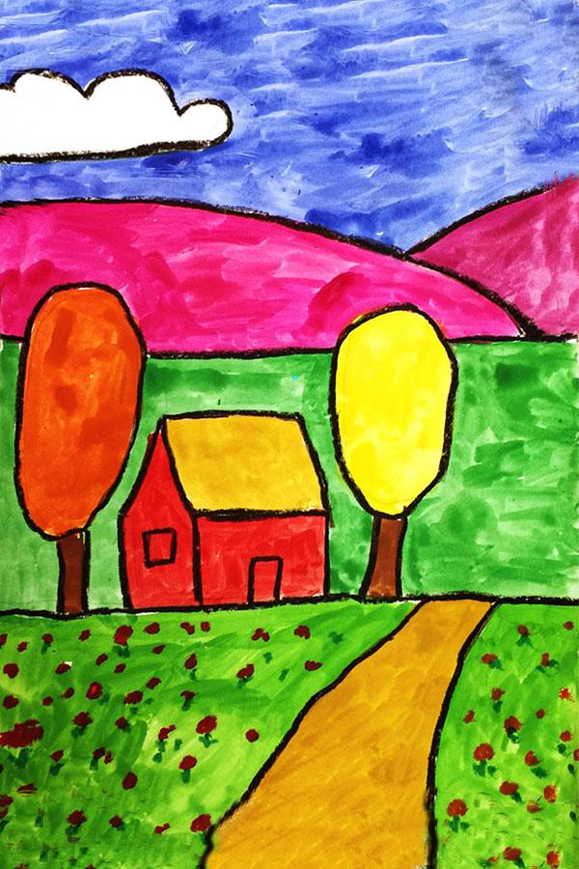
Landscape with simple foreground, midground, and background layers.
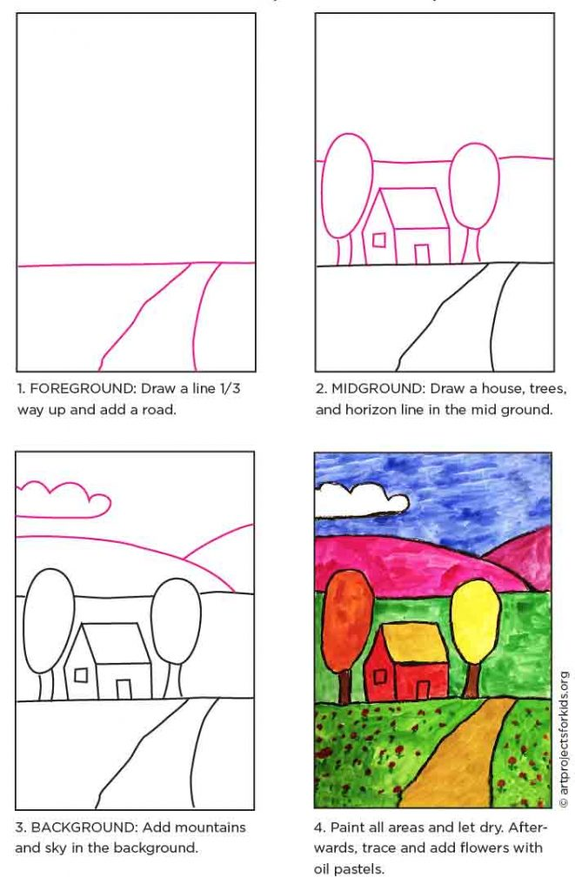
A good middle step between just drawing a house and trees, and drawing a house and trees with perspective, is adding layers of space to your art. A very simple way to approach that is to think of it in three sections — foreground, middle ground, and background.
This drawing has a very simple example of these layers. If you are up to pushing the space idea even further, try adding large flowers up front, near the bottom, and then tiny ones further back.
MATERIALS
- How to Draw Space in a Landscape Handout
- Paper
- Pencil
- Crayons/markers or something else to color with

DIRECTIONS
Time needed: 1 hour.
How to draw Space in a Landscape
- Draw the landscape foreground.
- Draw the midground with the trees and house.
- Draw the background with the mountains and sky.
- Color your landscape

