TICKET ORDER FORM

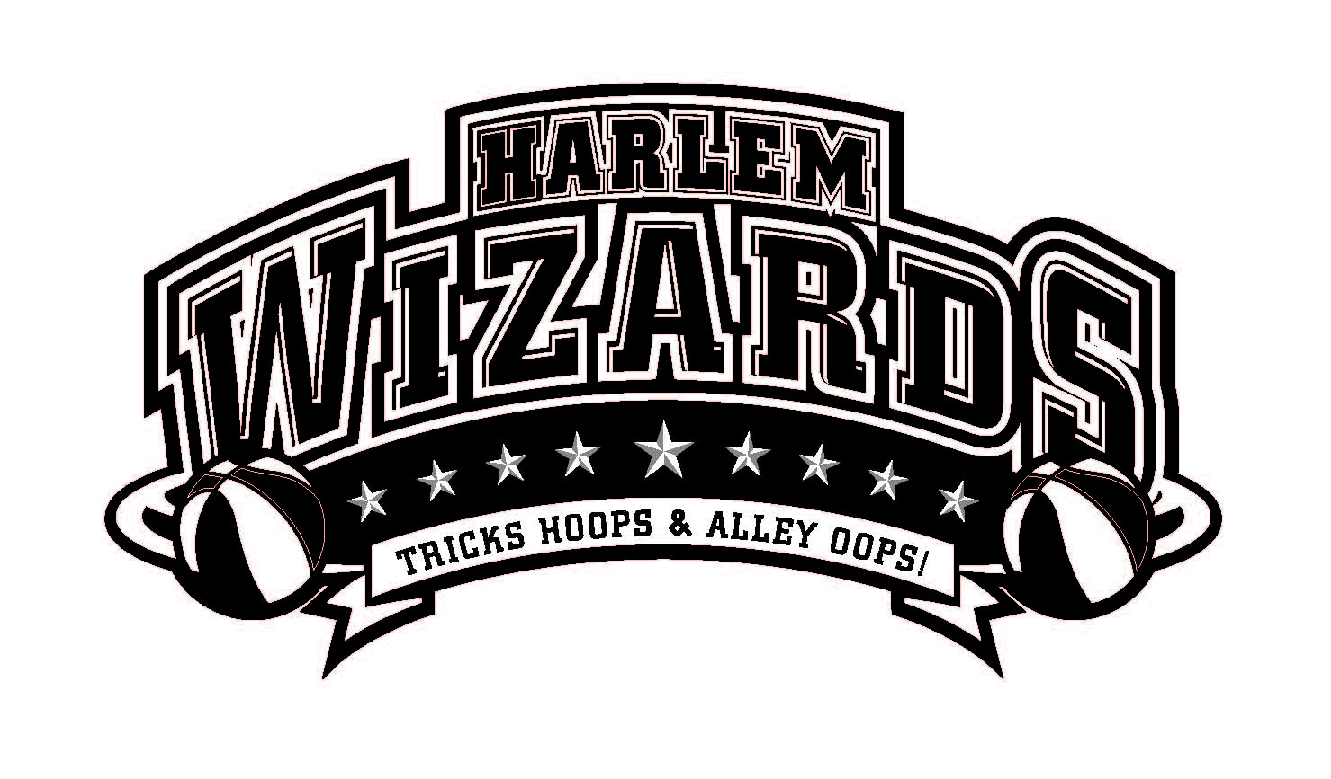
The Vault All-Stars
Featuring: Local Teachers and
Community Leaders

VS

This Slamtastic Community Event Hosted By: The Vault

***ORDER YOUR TICKETS NOW! WIZARD GAMES SELL OUT ALL OVER THE COUNTRY!***

Date | Monday, October 22, 2018 |  | Ticket Type | Advance  Price | Door  Price | # of tix | Total
Time | 6:30pm (Doors open @5:30pm) ) |  | Student | $9 | $11 |  | $
Venue | Clinton High School |  | Adult | $11 | $13 |  | $
Fundraiser for: | The Vault Teen Community |  | Reserved* | $17 | AVAILABLE ONLINE ONLY  Visit website to purchase
 | Center |  | Courtside Plus** | $25
 |  |  | Total |  |  |  | $

*Special reserved seating close to the court and free poster voucher
**Courtside seating (maximum 50), 10 minute meet & greet with 2-3 Wizards, souvenir lanyard, free team poster, and $10 discount on Wizards replica jersey. Arrive at the gym 1 hour before game time

Special Opportunity to Warm up with the Wizards! (Maximum 75 kids)
Become a “Wiz Kid!”- With purchase of Wizards replica jersey you will be
able to join the players on the court for some pre-game fun! Experience includes:
- Personal introduction to crowd as a “Wiz Kid” member by our MC!
- Warm-up with the Wizards (beginning 30 minutes prior to game)!
- Participation in the Wizards grand entrance!
- Group photo opportunity with both teams

Order your jersey(s) now at www.harlemwizards.com* and pick up at the Wizards Souvenir Store when you arrive!
*Go to Schedule & Tickets, search for your event date, and click the blue select button to purchase*
**In the event that your selected size does not fit or is unavailable, you may change sizes, or receive a full refund**

Total $ amount of Tickets Ordered: $__________

Student name____________________________ School_____________________________________
Parent name___________________________ Phone #____________________________ Email_______________________________________

CASH AND CHECKS ARE ACCEPTED or buy your tickets online @ www.harlemwizards.com

*Limited # of Court Side Plus/Reserved tickets *Non-Refundable*
*Order does not guarantee purchase *We will notify you if tickets are sold out *
Please return this form to First Christian Church. Tickets may be picked up at that location. Tickets will also be for sale at the Home Coming Football game on 10/5 or at The Vault Grand Opening on 10/14
For questions, call Mandi at 935-3139. Make checks payable to: The Vault.
THIS IS NOT A DROP OFF EVENT – K-6 STUDENTS MUST BE ACCOMPANIED BY ADULT

